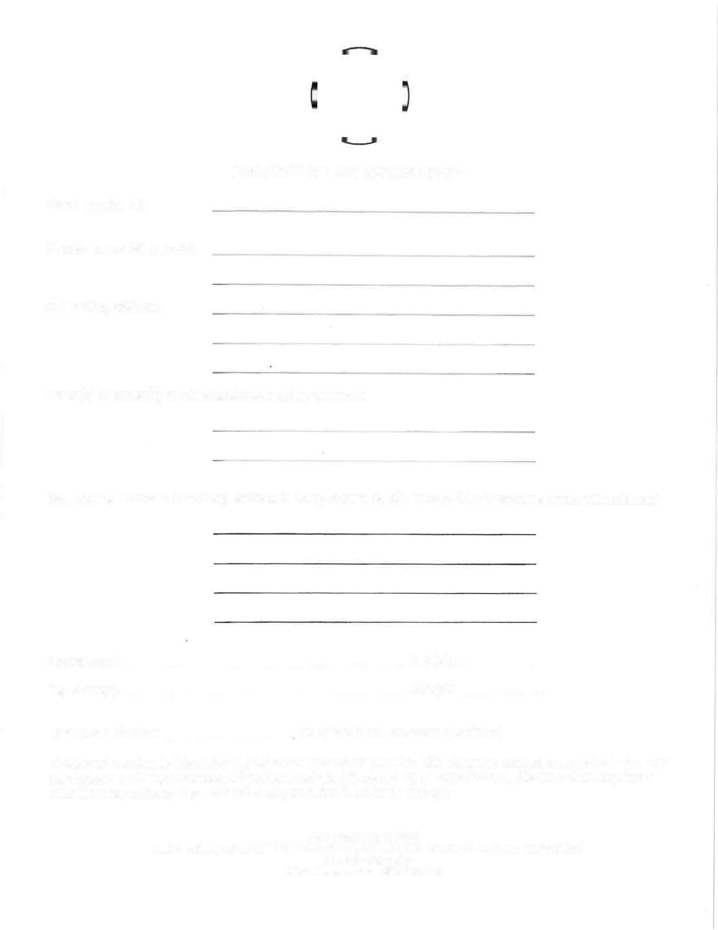
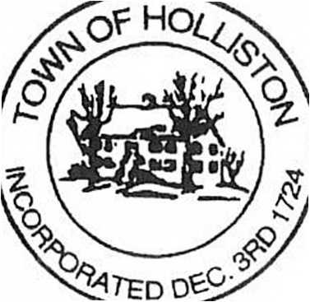

CHANGE OF ADDRESS FORM
Parcel number(s):

Deeded owner(s) name(s):

Old mailing address:

Name(s) of owner(s) to which address is being changed:

New Mailing Address: (If mailing address is being sent to as c/o, please list c/o person's name with address)

Signature(s): Date(s):
Signature(s): Date(s):

Telephone Number (Required if we have any questions)

The parcel number is listed above your name printed on your tax bills. Only the deeded owner(s) can change the address (if multiple owners, all parties must sign) If owned by an organization, this form also requires a letter from an authorized person of the organization in order to change.

ASSESSOR'S OFFICE
TOWN HALL, 703 WASHINGTON STREET, HOLLISTON, MASSACHUSETTS 01746-2168 TEL: 508-429-0604
Website: www.townofholliston.us

