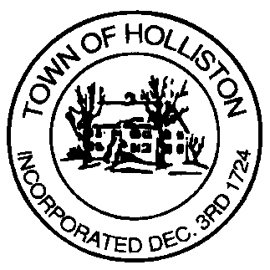
Town of Holliston
Commonwealth of Massachusetts
Conservation Commission

The following rules apply to land owned by the Town of Holliston and under the control and protection of the Holliston Conservation Commission. Conservation land is open to the public for passive recreation and other activities that adhere to the purpose of the land as acquired by the Town.
All users of Conservation Land must comply with any posted signs or verbal directions given by Holliston Police Officers, Holliston Conservation Commissioners, or the Holliston Conservation Agent. All users are expected to be respectful of the land and others using it.
Hours: Open ½ hour before sunrise. Closed ½ hour after sunset.
Prohibited Activities:
- Littering or dumping of any materials (including dog waste);
- Possession of alcoholic beverages or glass containers;
- Smoking;
- Hunting and trapping;
- Discharging of firearms, arrows, explosives, paintballs or any other projectiles;
- Collection of wildlife or plant material;
- Harvesting of wood;
- Introduction of any non-native wildlife or vegetation;
- Clearing of vegetation for the creation of new trails;
- Unauthorized construction of any permanent or temporary structures;
- Operation of motor vehicles including, but not limited to, motorcycles, dirt bikes, ATVs, OHVs and snowmobiles;
- Overnight camping, without written permission by the Holliston Conservation Commission;
- Fires, without written permission by both the Holliston Conservation Commission and Holliston Fire Department.
The walking of dogs on Conservation Lands is allowed and encouraged. However, dogs must be kept on leash and under control at all times.
Vehicles must park in designated parking areas or, where unavailable, safely along public roads.
The Conservation Commission reserves the right to amend these rules and to prohibit any inappropriate activities not specifically listed above. These rules do not override specific deed restrictions or other federal, state or town laws or regulations that may apply.
For questions and clarifications, please contact the Holliston Conservation Commission by phone (508-429-0607) or email (conservation@holliston.k12.ma.us)
The Holliston Conservation Commission thanks you for good land stewardship and in furthering our efforts to protect Open Space in Town. We hope you continue to use and enjoy this land to its fullest extent.

