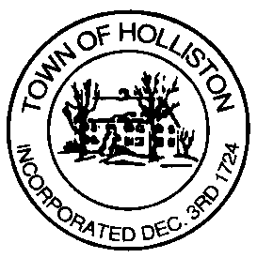

PART-TIME VAN DRIVER

The Holliston Senior Center is seeking a part-time van driver, to fill in as needed, to drive seniors and/or Veterans to appointments, senior center programs, grocery shopping, as well as deliver meals to homebound seniors. This involves driving a 10 passenger mini bus. A knowledge of Holliston and surrounding towns is desirable. Pre-employment physical, as well as drug and alcohol testing is required. Drivers must be willing to participate in all required trainings, including first aid, CPR, and wheelchair lift/securement. Experience with senior and/or disabled population is preferred. Being flexible, kind and compassionate is essential. Must pass CORI check, have valid Massachusetts Driver’s License and have a good driving record. This is a non- benefit eligible position. Compensation is $17.13 per hour, Grade 100, Step 1. Applications are available on the Town of Holliston website at https://www.townofholliston.us/employmentpersonnel/pages/job-opportunities and should be submitted along with a resume to the Town Administrator’s Office, 703 Washington Street, Holliston, MA 01746 or emailed to muzzyd@holliston.k12.ma.us. The deadline for applications is until the position is filled. The Town of Holliston is an EEO/AA employer.

